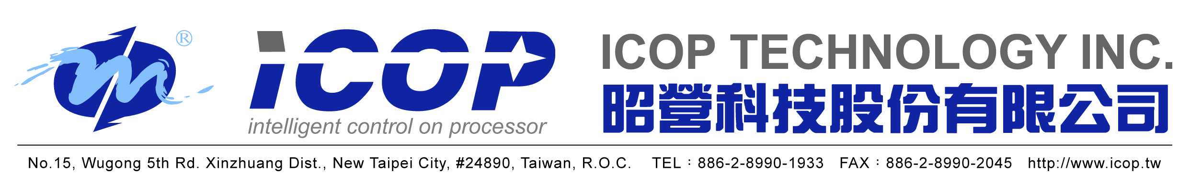

RMA Request Form

Date of Request:
Request Person/Company:
Address:
Phone / FAX:

Item Part No. | Qty. | Invoice No. | Serial No.

- Retuned items need to look new as original package.
- Restocking fee 20% of items’ cost will be applied.
- Customer must ship out returned items within 5 business day after getting ICOP RMA number.
- Customer will need to cover RMA items’ return shipping cost.
- Credit or refund will be offered after ICOP RMA dept.’s investigation showing returned items are in good as original condition.

RMA items need to be ship back to
ICOP Technology Inc. No.15, Wugong 5th Rd., Xinzhuang Dist., New Taipei City 248020, Taiwan

RMA Number assigned by ICOP Technology _______________ Date: ______________

